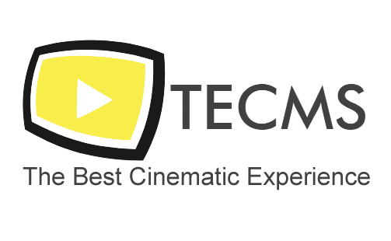

**REPORT # 021**

**The Eclipse Cinema Management System (TECMS)**

*“TECMS is a Cinema management system that organizes, simplifies, and maintains data to make any employee’s work easier!”*

Table of Contents

1- Meet The Team: 3

Jad Mrad 3

George El Raed 3

Louai Baydoun 3

2- Introduction: 4

3- Q&A: 4

Why TECMS? 4

What makes it special? 4

How do you handle being in-front of a screen all day? 4

What can I sell using this system? 4

How safe is it? 4

4- Project Timeline & Status 5

5- Project Maps & Details: 5

George El Raed 5

Jad Mrad 6

Louai Baydoun 7

6- Conclusions: 8

7- References: 8

# No table of figures entries found.

# 1- Meet The Team:

## Jad Mrad

* + Front-End (Interface)
  + Database (Saving/Loading)
  + Error Prevention (Exceptions)

## George El Raed

* + Food / Movies / Showrooms
  + Scheduling Operations
  + Seat Choosing Mechanism (+ Chooser GUI)

## Louai Baydoun

* + Employees/Customers + subclasses
  + Merchandise + subclasses/exceptions

# 2- Introduction:

TECMS is a system for both a standard Clerk operating a ticket and/or food sales booth and a manager who handles movies, showrooms, and other employees. The system is designed for simplicity and productivity making good use of Java’s Inheritance (1) process for minimal memory usage and maximal efficiency. We offer this program as a step towards a solution for long waiting times at cinemas and a platform to improve both the movie-going experience and the lives of everyone who works there.

# 3- Q&A:

## Why TECMS?

While other companies rely on tacky and over-used designs hoping to attract customers, we are the first in our field to tackle the other side of the transaction. TECMS focuses on the employees; what makes them work more efficiently, on what does their productivity rely, and, most importantly, how can we make that better! Flashy colors may be fun, but an enthusiastic and well-rested clerk can mean the difference between efficiency and loss.

## What makes it special?

We pride ourselves by deviating from the, though classic, use of the console for a more worker-friendly interface. Our system is intricately designed to offer the user upmost comfort and ease. New trainees can learn how to use our system in less than a day! We also managed to cut down the time for selling the ticket from a boring 4 minutes of entering data and hoping for no errors to the customer walking in, paying, and being out the door in less than 30 seconds!

## How do you handle being in-front of a screen all day?

TECMS has revolutionized the serving business by designing our system with a built-in *Blue Light Filter.* We primarily focused on using a color scheme that is easy on the eyes and can host an employee for upwards of 8 hours with minimal eye damage.

## What can I sell using this system?

Other than designing and printing out the movie ticket, our system can be used to also sell food and merchandise all while utilizing the same customers list.

## How safe is it?

We opted for a completely-offline system to be virtually un-hackable. A log-in sequence is also provided for an extra layer of security.

# 4- Project Timeline & Status

Due to cancellation of a previous project, work began on this project on May 28th and continued till the turn-in date of June 12th (later postponed to June 22nd). The project was divided over 4 days for planning and the remaining 11 days for designing. Trello and Discord were used for co-op work and communication. As of writing this report, the project has been successfully concluded and properly tested.

# C:\Users\DELL\AppData\Local\Microsoft\Windows\INetCache\Content.Word\GeorgeMap.png5- Project Maps & Details:

Figure 1 - Map A

## George El Raed

## Jad Mrad

Figure 2 - Map B

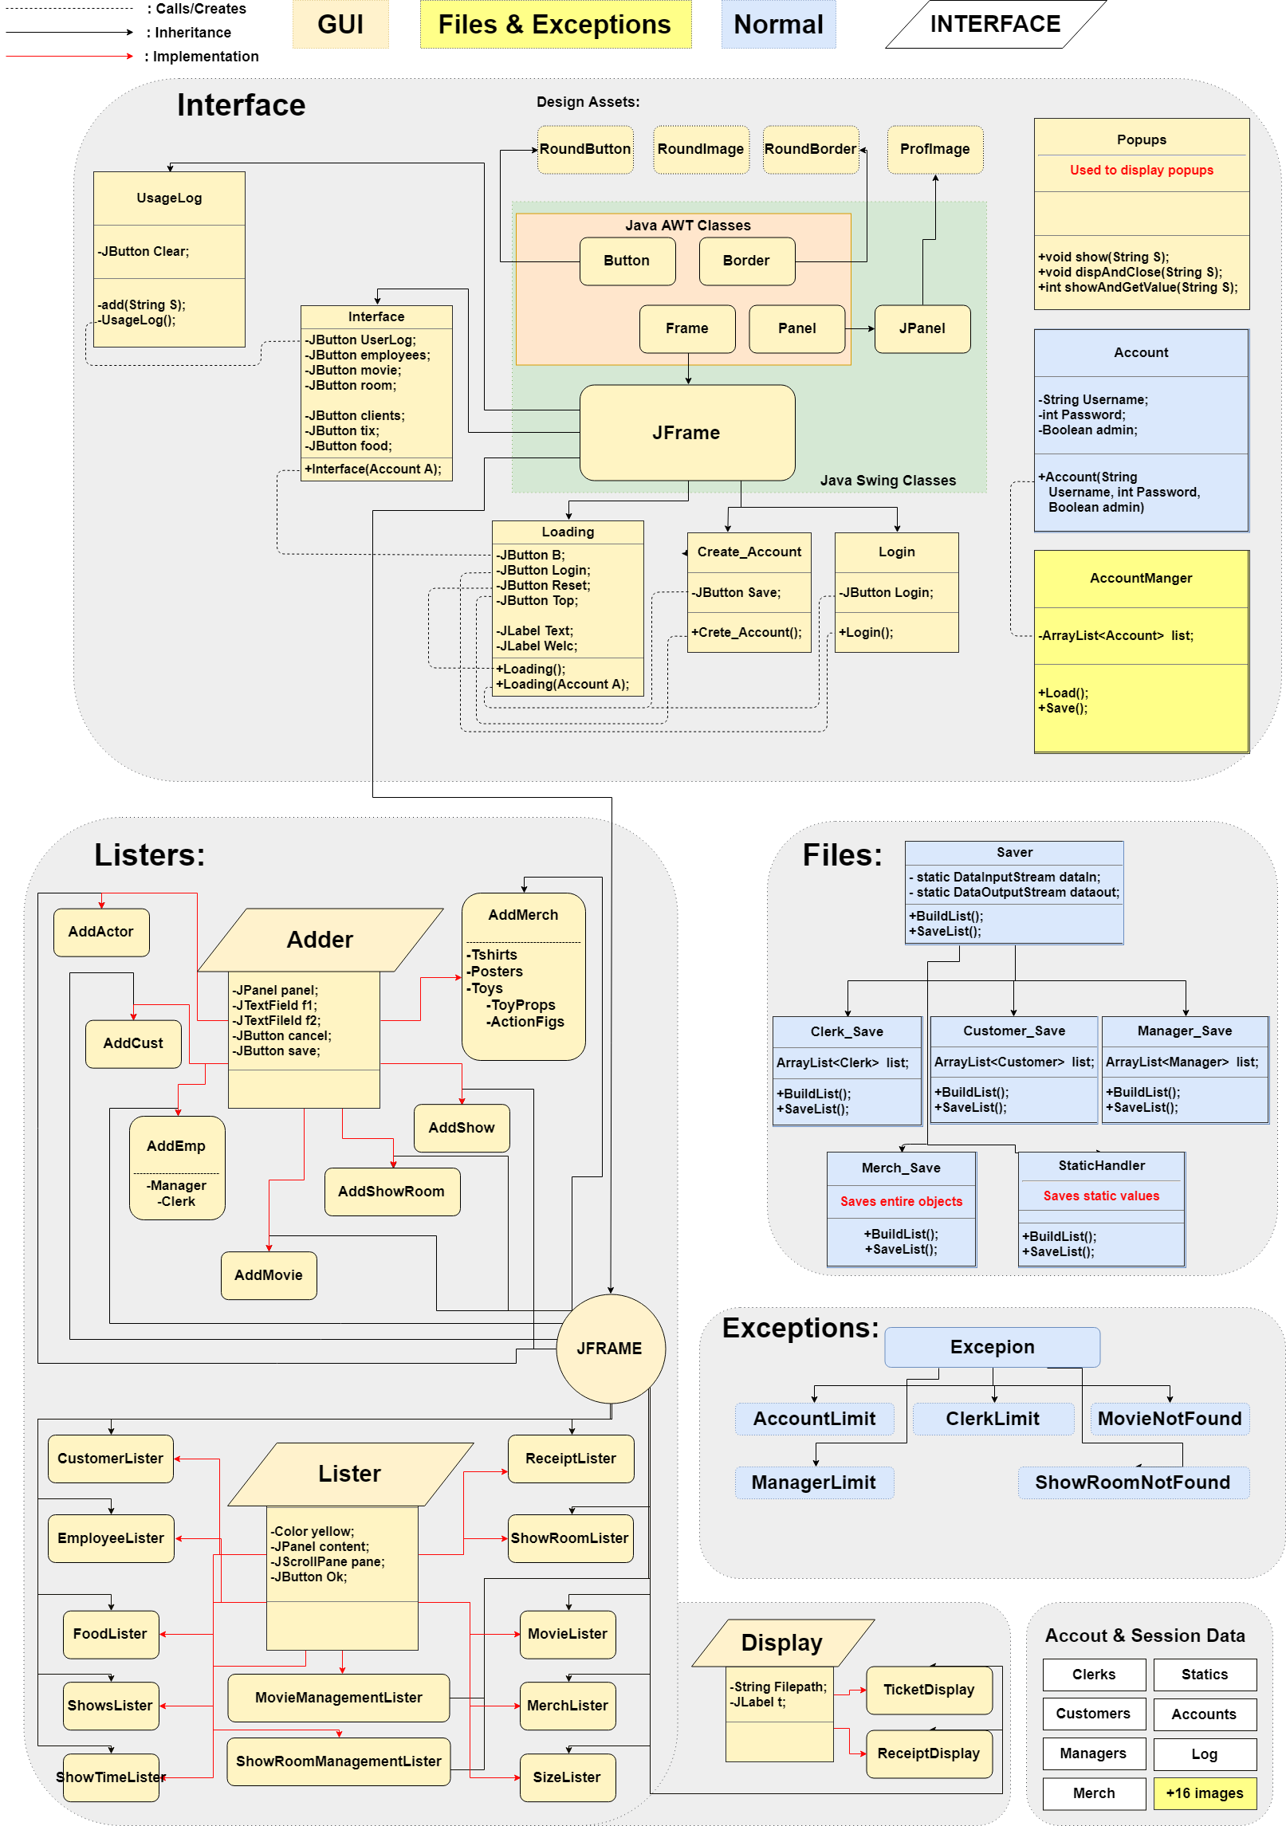

## Louai Baydoun

Figure 3 - Map C

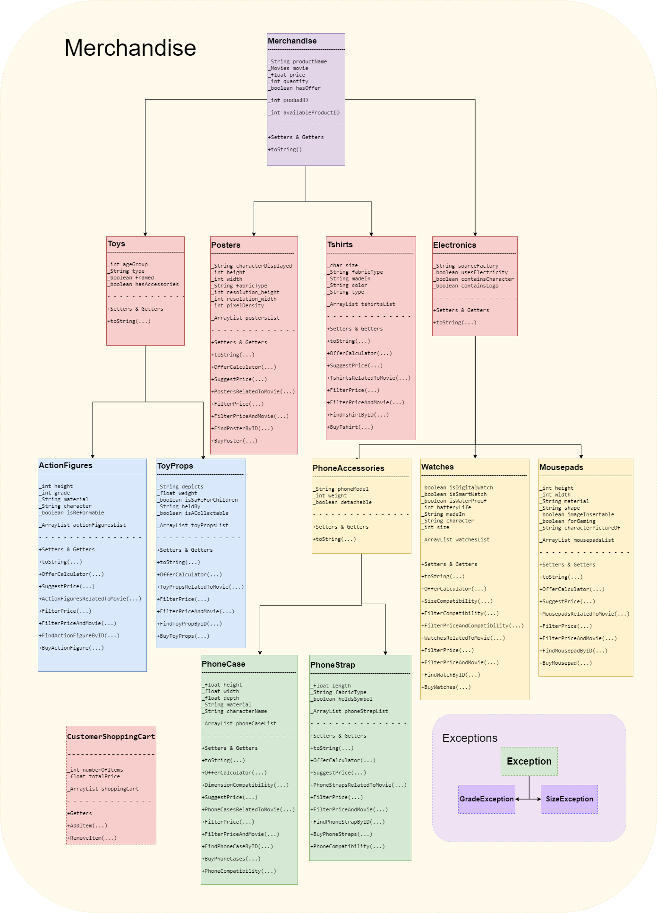

## 6- Conclusions:

TECMS is a step in the right direction for the future of managing, studying and manipulating data on a small scale on the road to **Big Data**. Improvements in every area of the system are needed if the program is, in the first instance, to survive and then grow. It must be remembered that this analysis is limited: a greater product is ensured once the user has cleared the creation of custom merchandise, tools, and statistics to help monitor his data. **Our goal was to ensure the proper in-flow of data**, and we believe we have done a great job at that. From there on, the sky is the limit. Together we strive for the best cinematic experience!

## 7- References:

1. **Draw.io** : Providing tools and data to organize our maps
2. **Trello :** Serving as a means of sharing a common checklist and better organizing the division of work
3. **Discord:** Establishing a means of communication between the team members throughout the process
4. **Eclipse & Netbeans** : IDEs used